LATEST HEADLINES

INTRODUCTION:

**OVERVIEW:**

An Android application for keeping up with the latest headlines is typically designed with the purpose of providing users with access to breaking news stories in a convenient, easy-to-use interface. The app would typically feature a variety of news categories, allowing users to select specific topics of interest such as politics, sports, entertainment, or local news.

The application would likely be designed with a clean and intuitive interface, allowing users to easily navigate between different sections of the app and access the latest news stories with just a few taps.

Some common features of such an app might include:

1. Customizable news feed - Users can select preferred news sources and topics. The app can then display articles and stories that match their preferences.

2. Breaking news alerts - Push notifications are sent to the user's device whenever a significant news event happens.

3. Social media integration - Users can share stories on social media platforms like Facebook or Twitter, and even post comments or reactions to specific articles.

4. Personalization features - The app can offer tailor-made news feeds based on a user's interests, previous reading history or location.

5. Offline reading - The app can allow users to download articles and read them later when they may not have internet access.

Overall, an android application for keeping up with the latest headlines is intended to offer convenience while providing access to timely information to users on the move.

**PURPOSE:**

The primary purpose of an android application for keeping up with the latest headlines is to provide users with quick and easy access to the latest news stories from around the world. With so much news available from a variety of sources, it can be challenging to keep up with all the latest developments.

An android application for staying up-to-date on the latest headlines can help to streamline the process of consuming news by presenting users with relevant stories from a variety of sources in one central location. This can save users time and effort in searching for news stories across multiple websites or individual news apps.

Another purpose of these apps is to allow users to stay informed on topics that are of particular interest to them. Many such apps allow users to customize their news feed preferences, so they only see stories related to topics like sports, politics, or entertainment, based on their preferences. By providing such customizations, the app provides a more personalized reading experience, keeping users more engaged.

In summary, an Android application for keeping up with the latest headlines serves the purpose of offering users a convenient and customizable way to access up-to-the-minute news stories in one central location, saving time and providing a more personalized reading experience.

**EMPATHY MAP:**

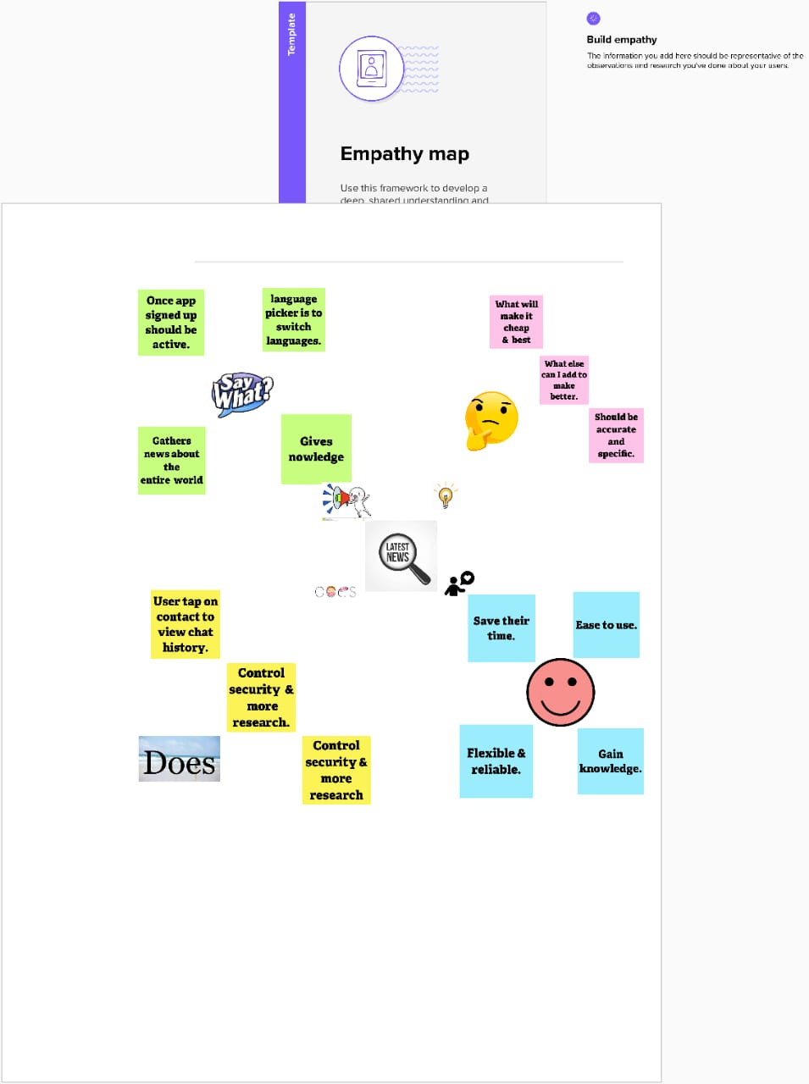

**BRAIN STORMING:**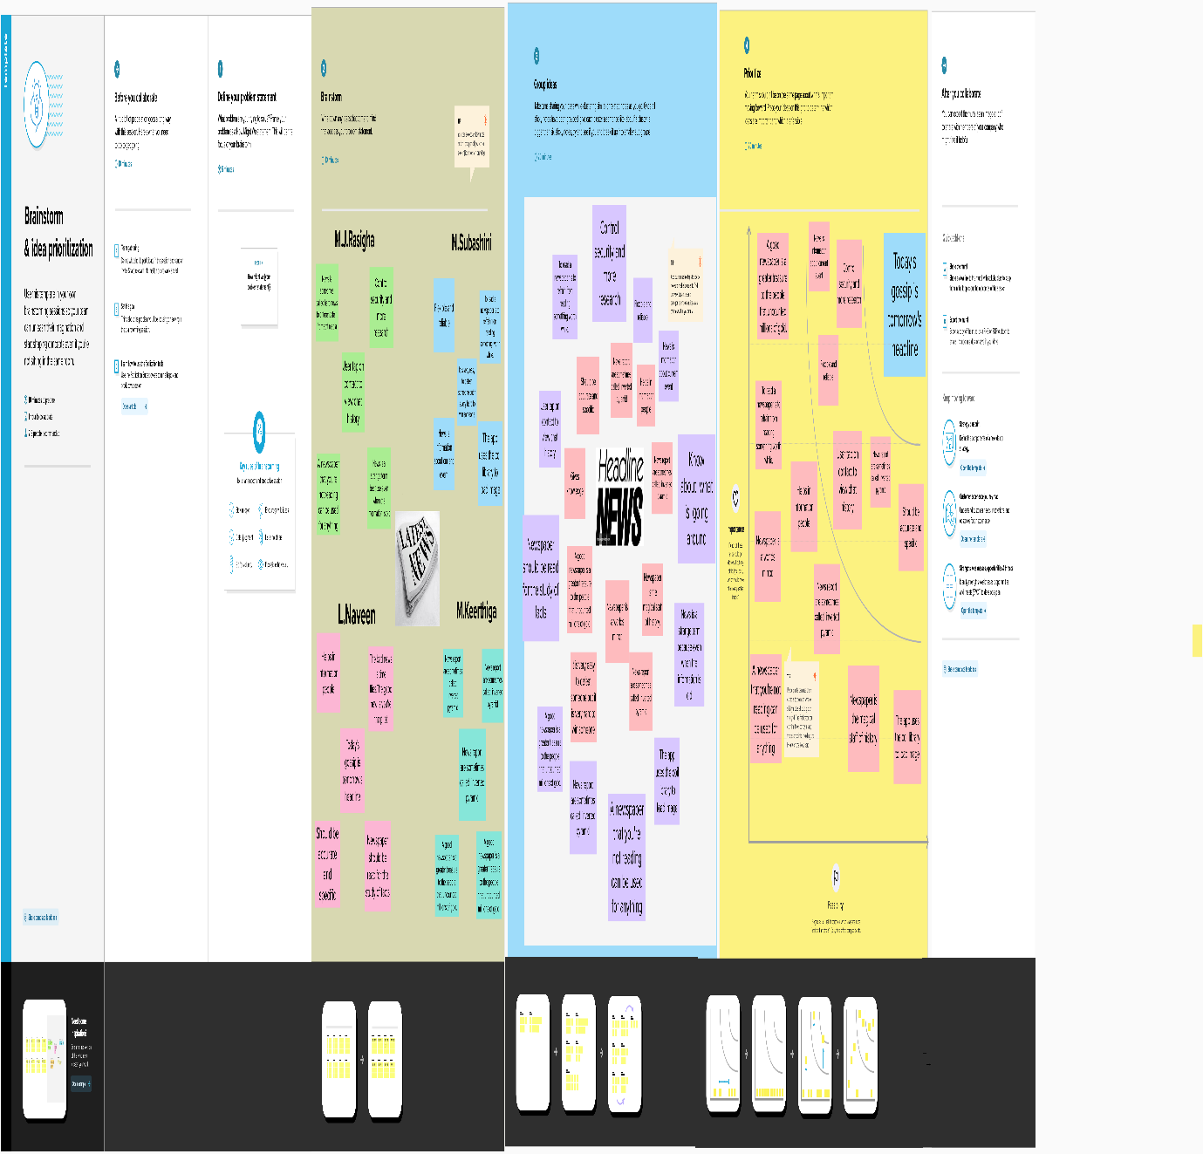

**RESULT:**

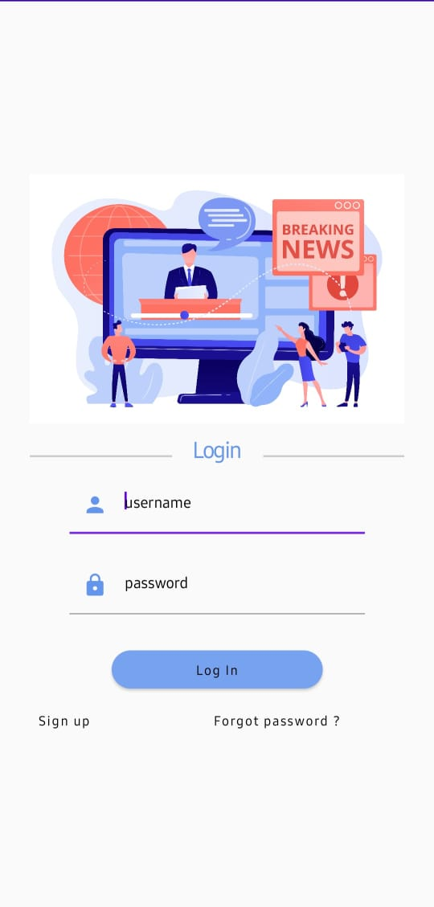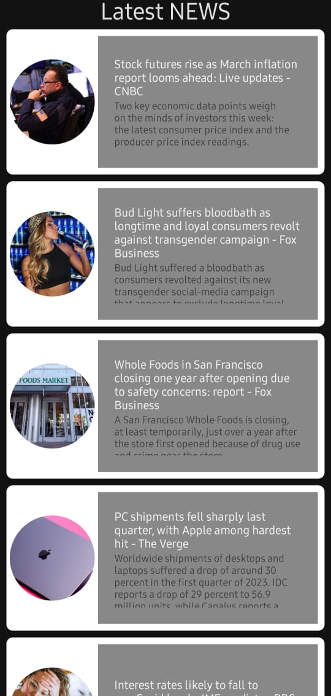

**ADVANTAGE**:

There are several advantages of using an Android application for keeping up with the latest headlines, including:

1. Convenience: With an Android app, users can access the latest news stories from anywhere and at any time. They don't need to wait for printed newspapers or tune in to broadcast news programs.

2. Personalization: Many news apps allow users to customize their news feed based on their interests and preferences, making the news more relevant and appealing.

3. Speed: News apps provide real-time news updates, which means users can get the latest news as it happens.

4. Large Selection: With an Android app, users can access news from a variety of sources from around the world, providing a broad selection of stories and diverse perspectives.

5. Easily Shareable: Most Android news apps support social media sharing, making it easier for users to share news stories with their friends and family quickly.

6. Multimedia: News apps can offer more than just text stories. Many news apps come with multimedia features, including videos, images, and podcasts, offering users different ways to consume news.

7. Alerts and Notifications: Some news apps provide breaking news alerts and notifications to users, keeping them up to date with the latest of what's happening.

**APPLICATION:**

An Android application for keeping up with the latest headlines can have many applications, including:

1. News and Current Affairs: It can be used to access the latest news and current affairs from around the world, including breaking news and trending topics.

2. Personalized News: It can personalize the news feed to the user's preferences, allowing them to get news tailored to their interests.

3. Notifications: It can send notifications to the user whenever there is an update on the latest news headline.

4. Bookmarking: It can allow users to bookmark articles and stories for later reading.

5. Sharing: Users can share articles and stories with their friends and family through social media platforms or messaging applications.

6. Offline Reading: It can provide the option of downloading articles and stories for offline reading, even when there is no internet connection.

7. Audio/Video: It can provide audio or video news feed, for those who prefer this type of media over reading.

Overall, an Android application for keeping up with the latest headlines is a powerful tool that can keep users informed and up-to-date on the latest news, while also providing them with options for customization, sharing, bookmarking and accessibility.

**CONCLUSION:**

In conclusion, an Android application for keeping up with the latest headlines is a valuable tool for staying informed and aware of current events. By providing personalized feeds, the ability to bookmark and share articles, and offline reading capabilities, it ensures that users can stay connected to the news, even on the go. Notifications also help users stay up-to-date on breaking news, while audio and video options provide extra accessibility. With its many features, an Android application for keeping up with the latest headlines is an essential application for anyone who wants to stay informed and connected in today's fast-paced world.

**FUTURE SCOPE**:

The future scope of an Android application for keeping up with the latest headlines is vast and exciting. Here are some potential possibilities:

1. Integration with AI: The application can leverage machine learning algorithms to personalize news feeds even further by analyzing user behavior, interests, and preferences.

2. Augmented Reality (AR) and Virtual Reality (VR) integration: AR and VR integration can provide users with immersive news experiences where they can see news stories come to life, adding a new dimension to the reading experience.

3. In-app live streaming: The application can incorporate live streaming of news events, speeches, and press conferences, making the user experience even more engaging.

4. Blockchain technology: Blockchain technology can provide transparency and trust in the news sources and their authenticity.

5. Multilingual options: The application can enable users to choose their preferred language to receive news feeds by incorporating natural language processing (NLP) technology to facilitate seamless translation.

6. Social media integration: The application can integrate social media platforms, enabling users to share their favorite news stories with their friends seamlessly.

Overall, with the ever-evolving technology and user demand, the future of an Android application for keeping up with the latest headlines is constantly expanding and offers endless possibilities for enhancement.